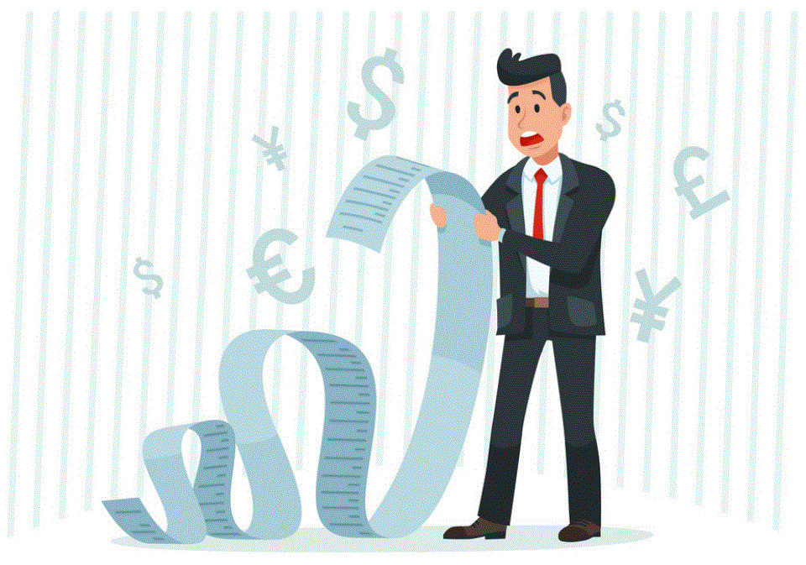

**Household   
Income &  
Expenditure**

BY SAJEEWA

Capstone project

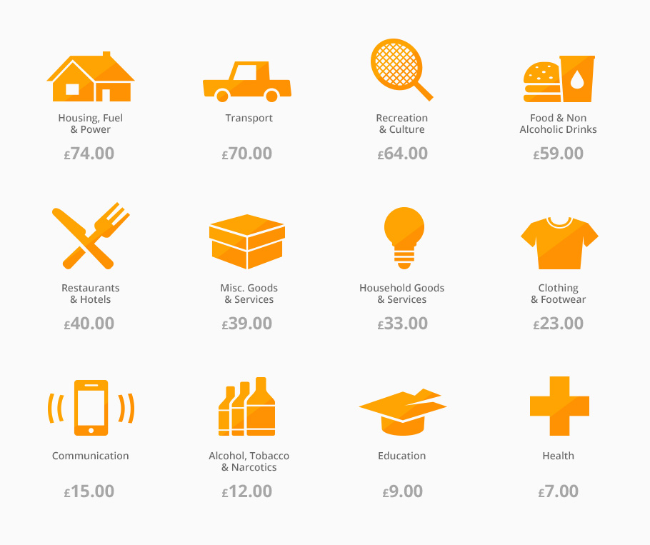

**Business Question?**

* How expenditure impact the Household income?

**Data Question?**

* Household income relate on the way we spend?

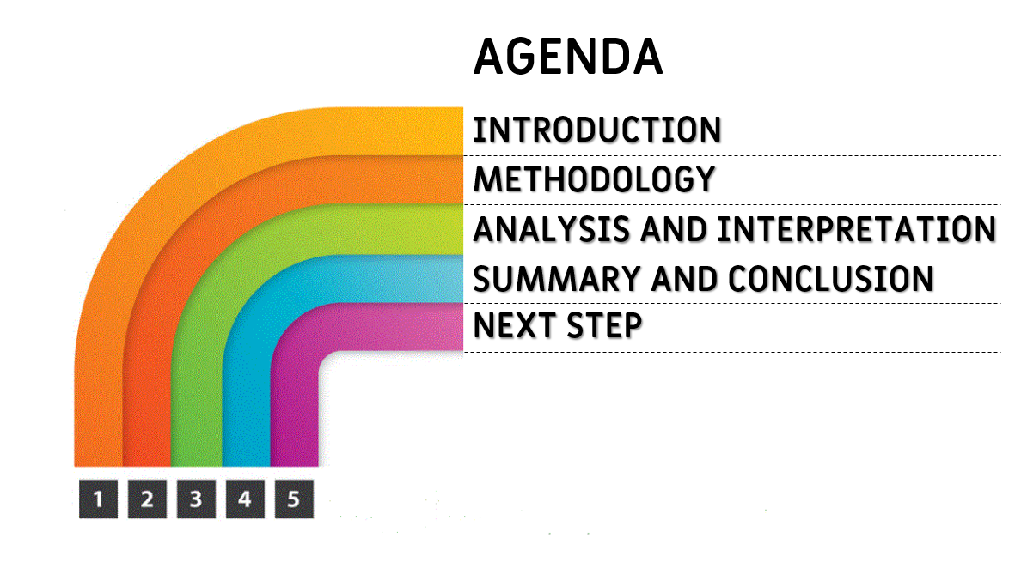

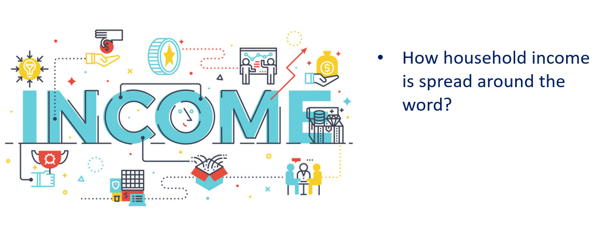

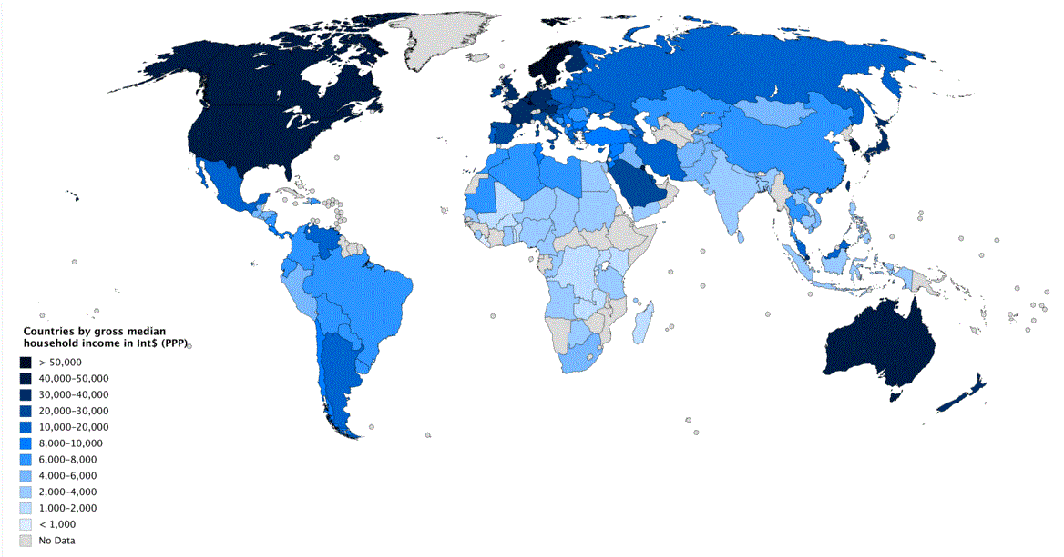

**HOW WEALTH THE COUNTRIES AROUND THE WORLD**

This map shows the median household income around the world. Darker the color --> Increases level of Income. America, European countries, Japan and Australia and New Zealand have darker colors. Even mid-east countries, the same. They categorized as develop countries.

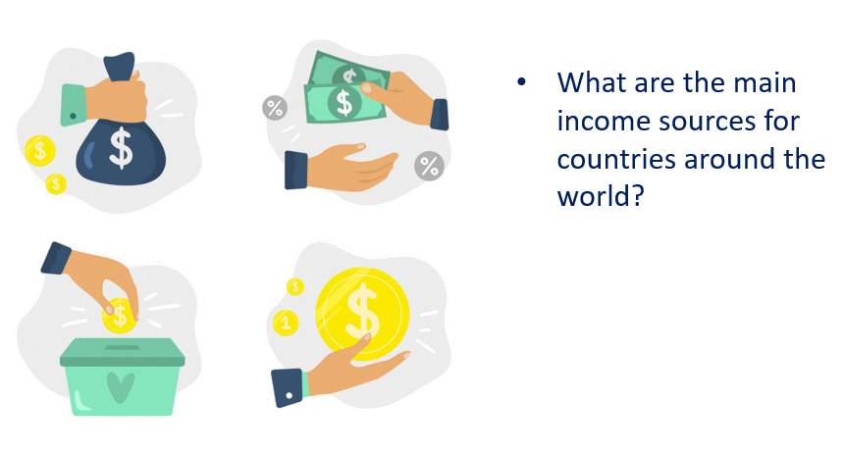

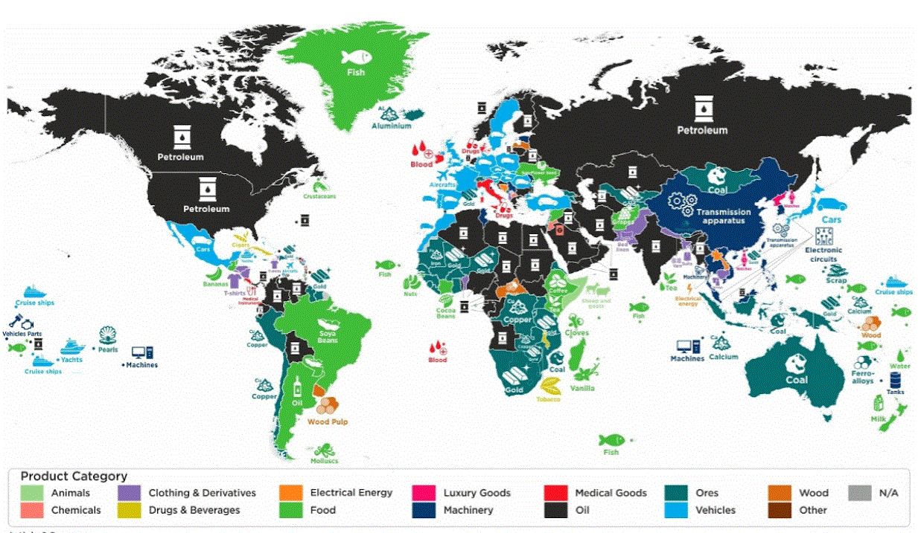

**MAIN INCOME SOURCES**

Maps shows the main income source around the world. Graphs has several categories. For an example South Africa’s main income is from GOLD. Japan’s export of motor vehicles. New Zealand Dairy Products. Yes.. Australia, Because of Coal.

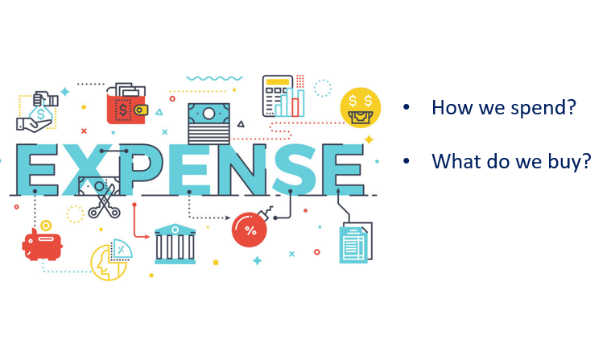

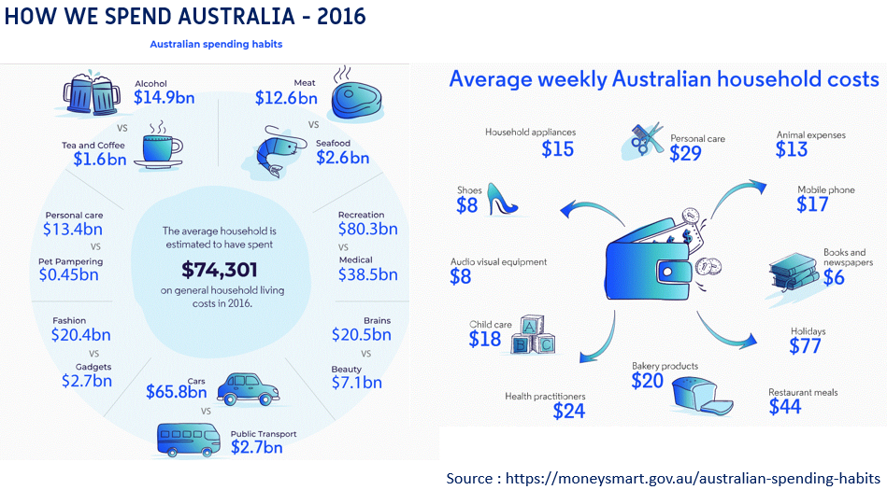This is how we spent money. This data is from 2016. Surprisingly we spent over $1.6 billion of dollars for just Tea and Coffee. With alcohol it was over 16.5 billion. That amount is great than what we spent on food. By weekly household cost we spend more on holidays $77 followed by Restaurant $44.

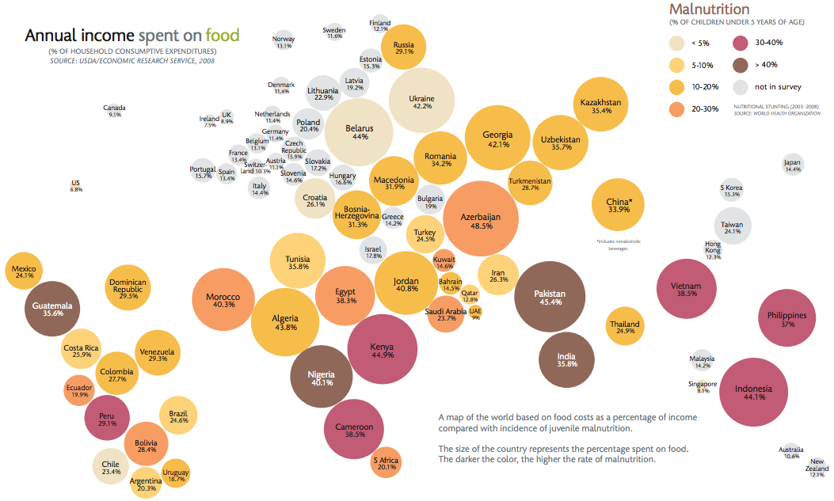

**SPEND ON FOOD**

Graph shows Income spent on food around the countries.

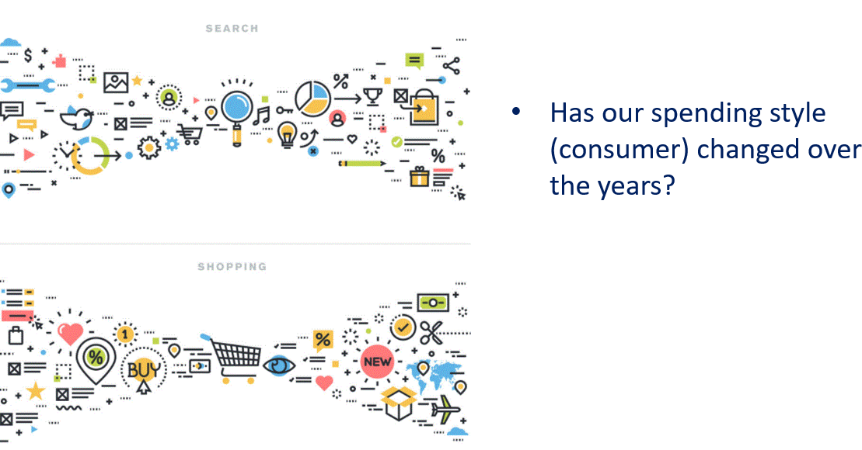

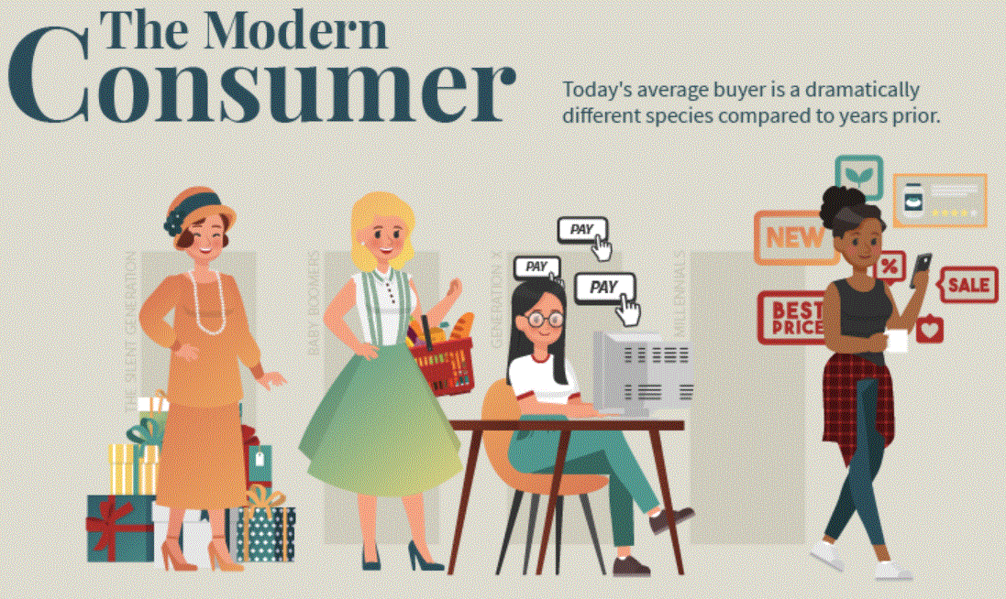Consumer today is almost unrecognizable to those decades ago. So, both businesses and investors will need to fully adapt to this new reality.

**MODERN CONSUMER…**

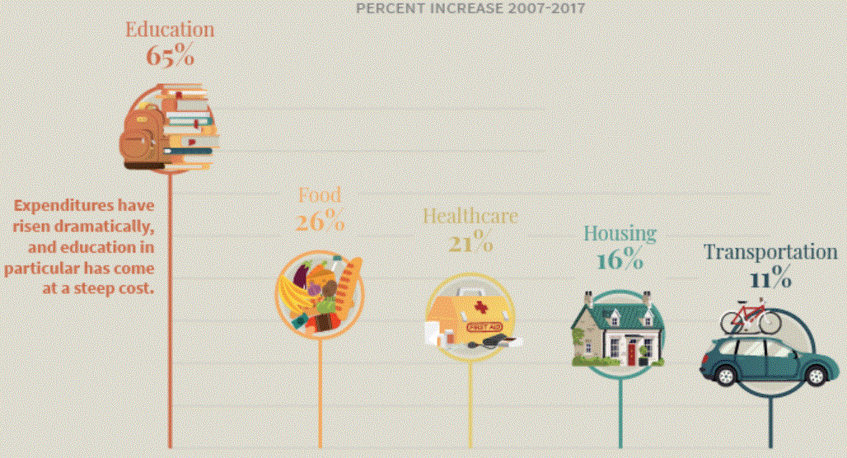Today’s Consumer is most educated in history and most in debts.

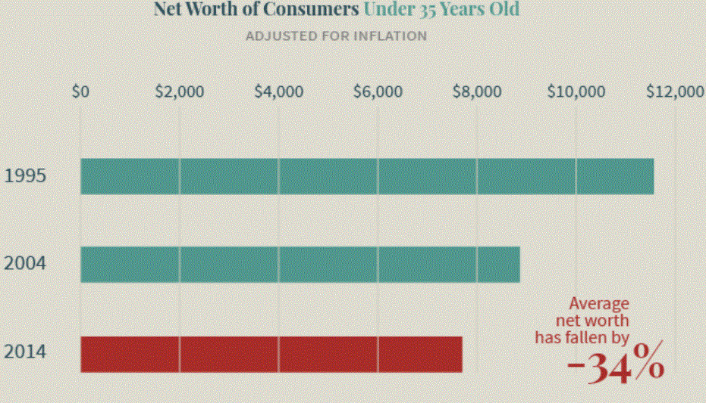

Young generations are also delaying key life milestones

Young generations are also delaying key life milestones

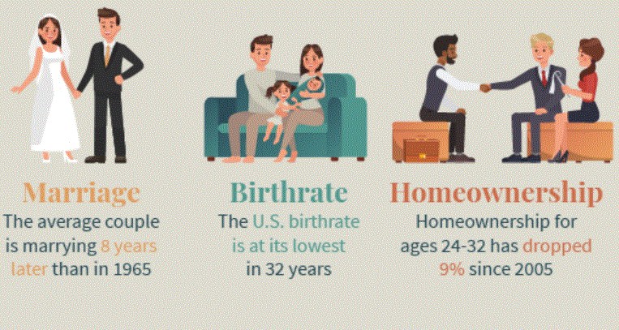

Young generations are also delaying key life milestones



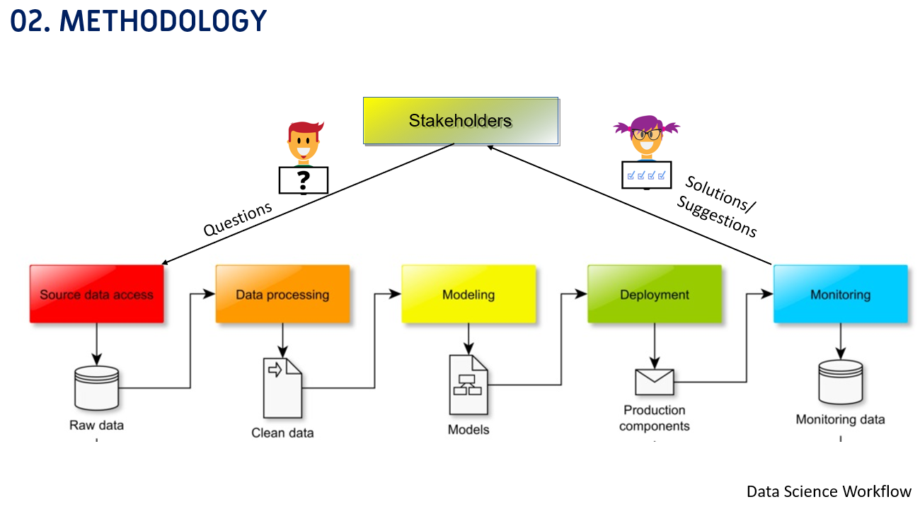This is my data science workflow. Firstly get the question/queries from Stakeholders. Then collect the data and data processing. Then testing and validating process. Then implementation and monitoring.

Finally... present the solutions and suggestions back to stakeholders.

